**Purpose**

To give an example of a QuickFlow program which takes a machine operator from machine setup to operation, dynamically changing variable CAD information to prevent error, tracking the required cycles to complete the router in a production environment to assure no parts were left unmarked (requires exact router quantity to be one of the items generated in the barcode), and accounting for the parts used to setup the machine – if they were good parts from the router or scrap setup pieces.

**Background**

These notes can be used be used to modify the file “Quickflow_Template” into an individual program that contains some static marking as well as variable markings. The QuickFlow module in TruTops Mark allows you to scan a barcode during a setup procedure to update these variable markings in real time, preventing operation error and facilitating a faster setup. These tests were performed on a Trumpf Workstation 5000 laser marking machine. This information was taken from a procedure at work and a lot was specific to them, so reading through it may seem discontinuous but for those familiar with TruTops Mark and interested in implementing the QuickFlow module with dynamic variable changes you should be able to gather what’s needed.

The Quickflow_Template is setup to run jobs with the rotary axis, or gang type fixturing, and contains example variables that could be changed to match customer specification, but the Quickflow program cannot contain commands that are not used during the cycle. These must be removed or altered before running the program based on an individual needs, meaning the template may contain too many marking options for some applications and is just a reference that must be edited before use.

In the examples below and in the template I’ve created fields to laser mark a customers part number, lot code, serial number, dimensions, etc, basic information that may change router to router in a production environment.

**Equipment**

PC with TruTops Mark software and Quickflow module installed.

CAD file with static and variable markings.

Barcode scanner (I used a Kercan KR-586 Wireless scanner, $30 on Amazon)

Barcode containing variables as a single string. There are many (free) barcode generating

softwares

**Definitions**

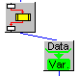CAD file – TruTops Mark vector file with extension .VLF

CAD software - TruMark_CAD.exe

*Objects & Connection:* 🡪

Object – Grey boxes within a .GIP file containing Quickflow functions.

Connection – Blue synchronization lines connecting two Objects.

Quickflow program – program file with extension .GIP

Quickflow software - Quickflow.exe

Variable – Storage location for data with a unique name identifier.

* 1. File creation
     1. Copy an existing CAD file with similar laser markings or create a new file with the CAD software and place the new / copied file into the directory you’re working out of. Rename the CAD file using a naming convention “DrawingNumber_Revision_Version” is an example. Start with version 1 if this is the initial program for this revision; for example “12345678_RevA_V1”.
     2. Setup the CAD file with variables  
          
          
          
        1. Open the CAD file. If this is a new file, select the “Text” function on the left hand side tool bar. If it’s an existing file that you want to change a static marking to a variable marking right click and select properties.

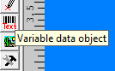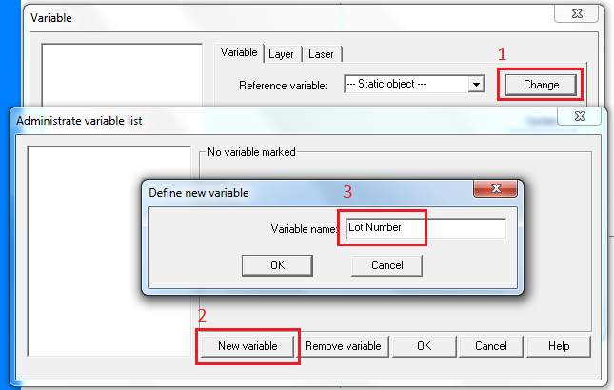

* + - 1. Click the Change button (1), New Variable (2), and then type the variable name you want to create (3), only one variable can be created at a time. The variable names must be consistent across all .GIP files. Click Ok on the “Define new variable” and “Administrator variable list” windows.
      2. 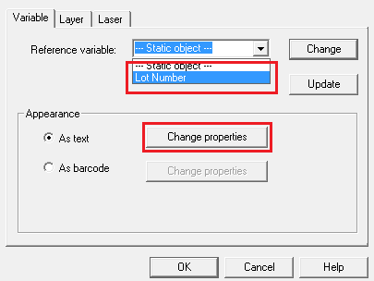Select from the Reference variable dropdown menu the name of the variable you just created. Then click Change properties.
      3. 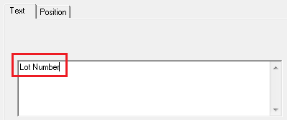Under the Text tab, type a name that represents the variable being made. It’s ok to use an abbreviation, for instance Dia instead of Diameter.

Repeat until all the variables are setup in the CAD file. Do not create any additional variables that will not be included in the laser marking.

Strip the Quickflow program. Use the color coded figure below to find the Objects to remove.

If the job to run is using the A (rotary) axis then skip this step. Otherwise, the program will be using the “gang type” fixture, so we must remove the A axis commands and setup message to align the fixture. Delete the Objects in Blue. It is not necessary to renumber Objects in the title block as some are deleted.



Open the three Objects controlling the Z Height by double clicking the Object (in Green on the figure below). The Constant option should be selected and the Z Height entered into the field below. Note: The Quickflow Z Height is in metric, unlike the TruTops Mark Z Height which is in inch.

Open the three Objects responsible for loading the CAD file (marked in Red). This is the directory and file name of the CAD file created in 5.1.3. Example: C:\Users\Jack\Desktop\new_folder\CAD_Quickflow_Test.VLF

Remove all Objects that load and define variables **not** being used in this Quickflow program. There are always two Objects for each variable back to back, one labelled *Pull* and one labelled *Set*, they’re marked on the figure below in Purple. Continue to relabel objects throughout the program to match the variables you created. This will make reading and troubleshooting the program much easier later.

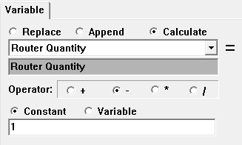If using the “gang type” fixturing, open the Object in Pink, this Object controls how many parts are subtracted from the router every cycle. Ensure that Router Quantity, minus ( - ) and Constant are selected and in the field at the bottom enter the total number of parts to be loaded into the fixture at once.

****All the Objects must have a connection going into and out of the Object (unless it’s the first or last in the program). This will generally only need to be done in areas of the program where Objects were deleted, taking the connections with them. To create a connection, select the Connect Object function from the tool bar below the main drop down menus. By clicking the bottom of one Object (six o’clock area) and the top of another Object (12 o’clock area) a connection will be made between both Objects. This is the flow the program will go through when processing, so it’s important Objects are only connected to the Objects directly above and below it. If a mistake is made, right click on an Object and select *Delete in Connections* or *Delete out Connections*.

Notes: Quickflow programs will typically hang up on Objects for minor mistakes to the program. To help with troubleshooting each Object has been labelled with a description of its function as well as a group designation. When a Quickflow program is running at the machine, this “title” is displayed at the top of the module so it’s known what step the program is on. The Quickflow program has “hung up” if it’s sitting at an Object for more than five seconds (excluding the Marking Object, which is time dependent based on the size of the marking). Use this information to quickly find the Object in question in the Quickflow program. The designations are as followed:

B = Beginning  
D = Decision  
S = Setup  
R = Router  
P = Production

